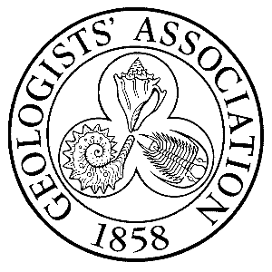
West of England group of the Geologists’ Association
OXFORD UNIVERSITY MUSEUM OF NATURAL HISTORY TRIP
Booking Form

Please complete this form and return to Kath Addison-Scott, by email to wega.talks@gmail.com or, to 44 Hebron Road, Bedminster, Bristol BS3 3AE

Date: 9th October 2025
Start Time: 12:00 pm
Finish Time: 15:30 pm approx.
Lunch: at the café or BYO
Location: OUMNH, Parks Road, Oxford OX1 3PW

Name: …………………………………………………………………………………….

Organisation: WEGA/BNS/BGS/SSi

Address: …………………………………………………………………………………
…………………………………………………………………………………
Contact Phone No.: …………………………………………………………………
Email Address: ……………………………………………………………………….
Emergency Contact Details - Name: ……………………………………………………………
Phone No.: ………………………………………………………

The Collections Tour fee is £10.00 per person. Refunds will only be made in the event that the trip is cancelled.
Please make payment by bank transfer to the West of England group of the Geologists’ Association:
Bank Account: 00210605 Sort Code: 30-99-38 Reference: OUNMH
Your place cannot be confirmed until payment has been received.
Cut-off date for booking & payment is the 1st of October 2025.
Please read the Risk Assessment before you book to ensure that this is an activity you can undertake safely.

I confirm that I have read and understood the Risk Assessment for this activity.

